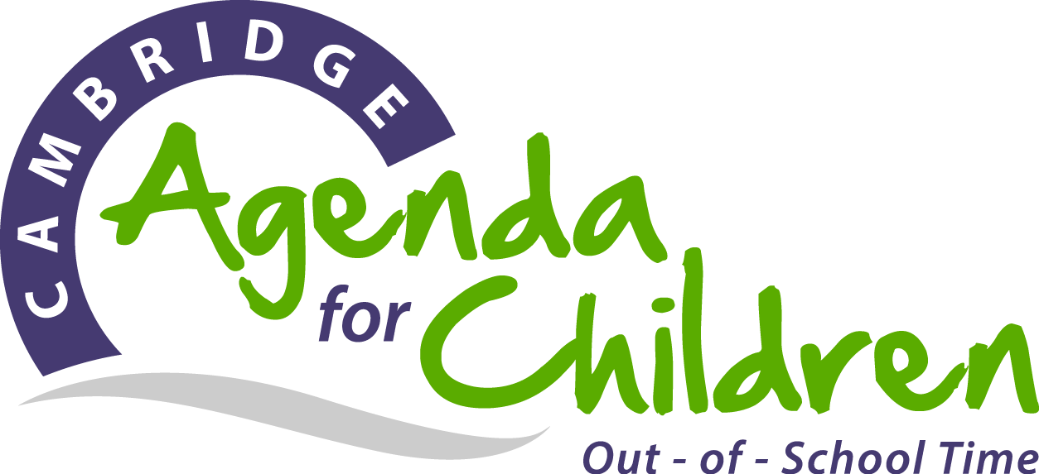
Professional Development Planning Template
There are many different “types” of professional development activities in which out-of-school time (OST) professionals may participate. Below is a sample planning tool based on the types of professional development common to the youth-serving field, OECD guidelines for education professionals & EEC professional development types.
Networks, Communities of Practice, Professional Learning Communities  (e.g. formed specifically for professional development of OST professionals) | Workshops  (e.g. on subject matter or methods and/or other youth development, education, and/or OST-related topics) | Conferences/ Seminars  (e.g. at which OST professionals and/or researchers present research results and best practices) | Qualification Program  (e.g. a degree or certification program) | Mentoring, Observation, Coaching  (e.g. as part of a formal OST program arrangement) | Observation Visits to Other OST Programs | Self-Guided Study  (e.g. reading professional literature)
Agenda for Children OST offerings
Communities of Practice  Youth Worker, Staff Leaders, Quality Stewards  7-8 sessions x 2 hours  Executive Directors  4 sessions x 2.5 hours  Middle School Network  8 sessions x 2 hours  EL Steam Network  2 sessions x 2 hours | Training  2-3 hours/ workshop, 12 workshops | OST Symposium  1.5 hour/ workshop, 8-10 workshops |  | Quality Improvement System (QIS)  10-30 hours
Networks, Communities of Practice, Professional Learning Communities  (e.g. formed specifically for professional development of OST professionals) | Workshops  (e.g. on subject matter or methods and/or other youth development, education, and/or OST-related topics) | Conferences/ Seminars  (e.g. at which OST professionals and/or researchers present research results and best practices) | Qualification Program  (e.g. a degree or certification program) | Mentoring, Observation, Coaching  (e.g. as part of a formal OST program arrangement) | Observation Visits to Other OST Programs | Self-Guided Study  (e.g. reading professional literature)
Your and/or other organization offerings
• RAY (Reaching All Youth) |  | • National Afterschool Association conference  • Coalition of Schools Educating Boys of Color | • Youth Work  Certificate Training  • Youth Work Supervisor Training | • Supervision  • Peer Supervision  • Staff/ Team meetings  • Orientations/ retreats

