JULIE MEHRETU
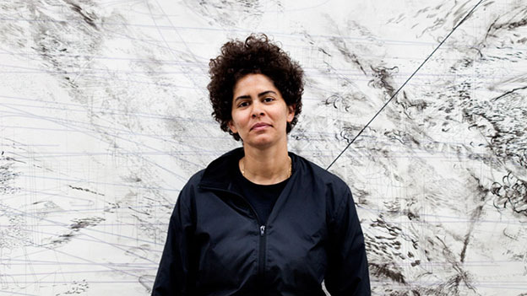
JULIE MEHRETU’s most expensive paintings sold for $4.6 million at Christie’s New York in 2013, and nearly $3.5 million at Christie’s London last year. | Photo by Mark Hanauer
Mehretu, who lives and works in New York, calls her abstract paintings “story maps.” Her narratives are formed via abstracted images of histories, cultures and geographies. Three years ago, she set an artist record when her 2001 painting “Retopistics: A Renegade Excavation,” sold for more than $4.6 million (including fees) at Christie’s New York. At auction, her large-scale canvases have been selling north of $1 million for years, consistently ranking her among the most expensive living women artists. In April, artnet ranked her No. 7; she is No. 1 among black female artists.

Angela Y. Davis
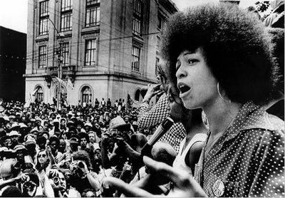
Angela Davis, born on January 26, 1944, in Birmingham, Alabama, became a master scholar who studied at the Sorbonne. She joined the U.S. Communist Party and was jailed for charges related to a prison outbreak, though ultimately cleared. Known for books like Women, Race & Class, she has worked as a professor and activist who advocates gender equity, prison reform and alliances across color lines.

Caroline Le Count (1846-1923)
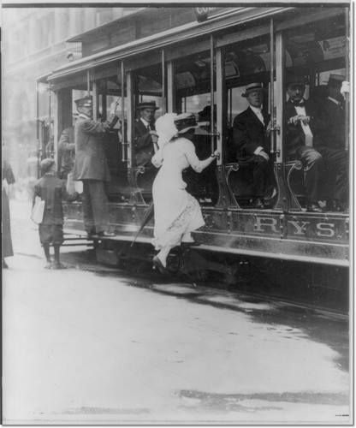
Caroline Le Count was an African American schoolteacher, who was also part of a women’s resistance campaign during the Civil War. The aim of the group was to cause civil disobedience in order to challenge segregation orders which kept black and white people separated in public areas.
Many of the women in these groups were involved in supplying troops and nursing wounded soldiers, yet were unable to ride the streetcars to transport them to bases many miles outside the city. Le Count and many of the other women had been forcibly removed from the streetcars on numerous occasions trying to reach the troops.
Due to increasing pressure from civil rights activists, the law regarding the streetcars was eventually changed. However when Le Count tried to board a streetcar on March 25th, 1867 the conductor was unaware of the new law, and shouted “We don’t allow niggers to ride!” Le Count complained to the nearest policeman who arrested the conductor and fined him $100.
Following this victory, all of Philadelphia’s streetcar companies were informed that segregation would no longer be tolerated. It was a small victory in terms of the civil rights movement as a whole, but allowed for the free movement of African Americans across the city of Philadelphia.
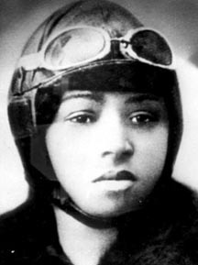

In 1922, aviator Bessie Coleman became the first African American woman to stage a public flight in America. Her high-flying skills always wowed her audience.
Bessie Coleman was the first black woman to earn a pilot's license. Because flying schools in the United States denied her entry, she taught herself French and moved to France, earning her license from France's well-known Caudron Brother's School of Aviation in just seven months. Coleman specialized in stunt flying and parachuting, earning a living barnstorming and performing aerial tricks. She remains a pioneer of women in the field of aviation.

Robert Smalls (1839-1915)
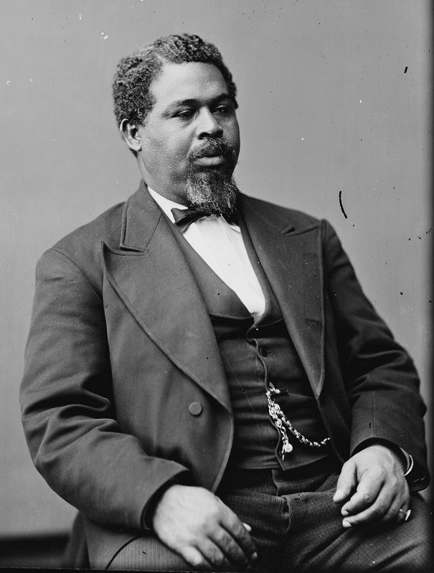
Robert Smalls was a slave from Beaufort, South Carolina, who was assigned to the CSS Planter, a Confederate military transport ship. In May 1862, while the ship’s three white officers were ashore in Charleston, Smalls and eight other enslaved crewmen stole the boat. Smalls dressed in a Captain’s uniform and sailed to a nearby wharf to collect all the crew’s family members who were hiding there. He was then able to manoeuvre past the five Confederate forts who were guarding the harbour by supplying the correct secret signals. Smalls sailed the ship past Fort Sumter and headed straight towards the Union ships, flying a bed sheet as a white flag. He surrendered the Planter and all its cargo, including a codebook to the US Navy. All of the crewmen and their families were freed from slavery, and Smalls was invited to meet President Abraham Lincoln and helped convince him to allow African-Americans into the US Army and Navy.
Smalls joined the service for the Union Navy, and in 1863 became the first black captain of a vessel in the US. After the war he became a politician and was elected to the House of Representatives as a Republican candidate for South Carolina. He was the longest-serving African-American member of Congress until Adam Clayton Powell Jr. As a politician, Smalls authored state legislation that gave South Carolina the first free and compulsory public school system in the United States.

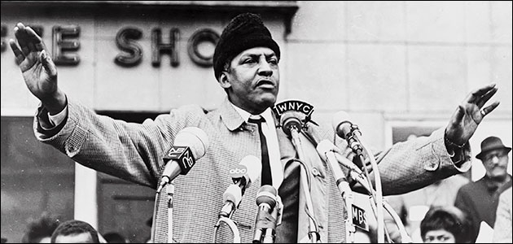
Bayard Rustin spent years in the background of the shadows of the great civil rights leader of the 1960′s, despite being the man who taught, organized and led them. Of all the leaders of the civil rights movement, Bayard Rustin lived and worked in the deepest shadows, not because he was a closeted gay man, but because he wasn’t trying to hide who he was. That, combined with his former ties to the Community Party, was considered to be a liability.

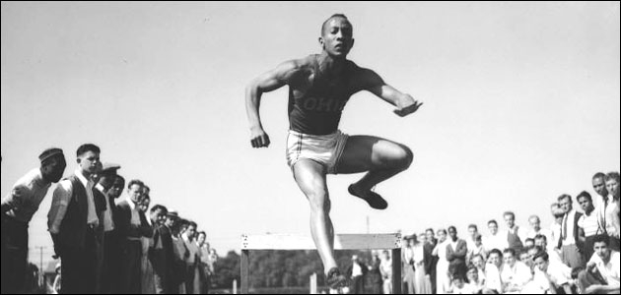
More than just a celebrated athlete, Jesse Owens took his country on his shoulders and shocked the world winning four gold medal in the 1939 Berlin Olympic Games.

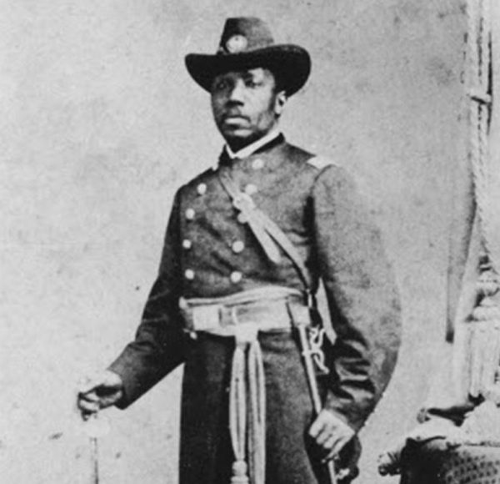
Martin Delany (May 6, 1812 – Jan. 24, 1885)
Martin Robison Delany was an African-American abolitionist, journalist, physician and writer. He was born free in Charles Town, W.Va. (then part of Virginia, a slave state). Delany was an outspoken Black nationalist, arguably the first; and is considered by some to be the grandfather of Black nationalism.
He was also one of the first three Blacks admitted to Harvard Medical School. Trained as an assistant and a physician, he treated patients during the cholera epidemics of 1833 and 1854 in Pittsburgh, when many doctors and residents fled the city.
Active in recruiting Blacks for the United States Colored Troops, he was commissioned as a major, the first African-American field officer in the United States Army during the American Civil War.

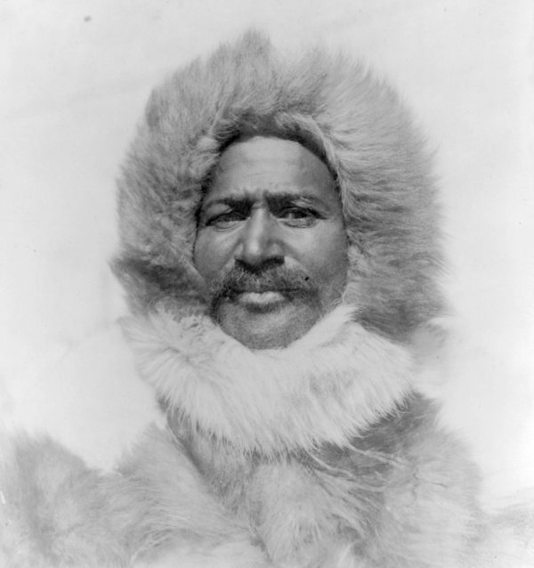
Matthew Henson (Aug. 8, 1866 – March 9, 1955)
Born to sharecroppers on a farm in Nanjemoy, Md., Matthew Alexander Henson became the first African-American Arctic explorer, and is credited by many as the first man to reach the North Pole, in 1909.
Henson was an associate of the American explorer Robert Peary on seven voyages over a period of nearly 23 years. Henson served as a navigator and craftsman, traded with Inuit and learned their language. He was known as Peary’s “first man” when it came to tackling the arduous expeditions.

Theaster Gates
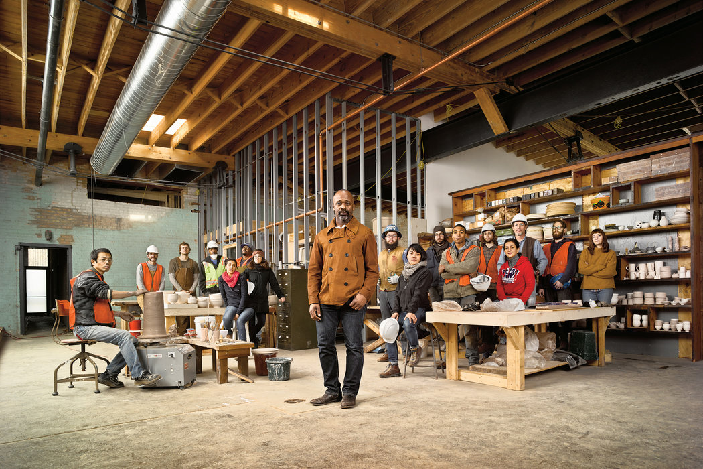
Theaster Gates is an American social practice installation artist. He was born in Chicago, Illinois, where he still lives and works. Gates' work has been shown at major museums and galleries internationally and deals with issues of urban planning, religious space, and craft. He is committed to the revitalization of poor neighborhoods through combining urban planning and art practices.
Gates was trained as a potter, but his artistic practice includes, among many things, sculpture, musical performance, installation and something that has been called large-scale urban intervention. Around the corner from the bank he purchased for $1 and raised $3.7 million to renovate, on the 6900 block of South Dorchester Avenue, he bought and restored a half-dozen other vacant properties as part of what has become his Dorchester Projects.

